Message from Administration

Discussing Discrimination: How can you talk to your children about diversity and discrimination? Here are some guidelines to keep in mind.

- Don’t expect to have “the talk” about discrimination. It shouldn’t be one conversation. Rather, let the discussion be open and ongoing.
- Use age-appropriate language children can understand, and don’t give kids too much information at once. The conversation will get deeper and more nuanced as they get older.
- Learn to respond to children’s questions about differences and bias as they come up naturally. Help children feel that their questions are welcome, or they might come to believe that discussing differences is taboo.
- Help children understand the value of diversity. A diverse set of experiences and viewpoints boosts creativity and helps kids (and adults) better understand the world around them. On the other hand, discrimination hurts everyone–not just the targets of discrimination. When people are discriminated against, we can miss an important opportunity to learn from them.
- Take opportunities to raise discussions based on what you see around you–in real life, books, television shows and even video games. You might ask: “There aren’t many female characters in this video game. What do you think of that?”
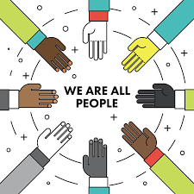
- Help kids learn how to deal with being the potential target of discrimination. Plan ahead by developing healthy comebacks or responses to hurtful discriminatory statements. For example: “What an unkind thing to say.” “Excuse me? Could you repeat that?” “I disagree with you, and here’s why…”
- Challenge your own assumptions and behavior. Do you laugh at racially insensitive jokes? Do you cross the street to avoid passing people of a different ethnic group? Children learn from your actions as well as your words.

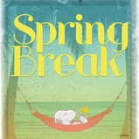
SPRING BREAK MARCH 14th – MARCH 28th

The school will be closed for Spring Break. We hope everyone has an opportunity to rest and do a few family activities during this break from routine. School will reopen for the third term on Monday, March 28th. Please refer to our school website for future dates and events.

NO PARKING AT BLAIR SCHOOL

Due to safety issues with students and parents walking across the parking lot to their cars and parked vehicles blocking the entrance to the driveway, parents are asked to not park along the entrance to the driveway, or along Lynas Lane where there are No Parking Signs. This endangers our students and staff. Also, there is no parking in the two handicapped parking stalls unless you have a handicapped tag displayed in your car.

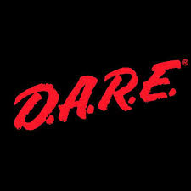
D.A.R.E. PROGRAM AT BLAIR

Our Grade 5 students will participate in the DARE Program beginning after Spring Break. DARE stands for Drug and Alcohol Resistance Education. It is a program developed by the RCMP and, in fact, we will have an officer from the Richmond detachment of the RCMP teaching the lessons to our students. The program runs for 10 weeks.

PINK DAY – OUTSTANDING!

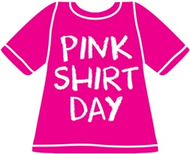
February 23rd was Pink Shirt Day – an anti-bullying awareness day. The students worked with their buddies in various ways to show Care For Others. The Student Leadership group created an anti- bullying video for all the classes to watch as well, which focused on using Helpful vs Hurtful words. Thank you to Mr. Chan, Mrs. Wood, Ms. Thomas and the Leadership Team for a wonderful video with a powerful message for all students.

Next Hot Lunch – April 1st, 2022 Reminder

After Spring Break the next hot lunch will be on Friday April 1st, 2022. Please ensure you have registered for “Munch-a-Lunch” account to place your order. You may find the link at our Blair School website or essentially use the link below to access the registration and order form to place your sushi order. Deadline to place your order online will be March 14th- March 27th 2022 at 11:59PM. Should you wish to not participate in this month’s hot lunch day, please pack a healthy lunch and snacks for your child on the day of. Teachers and staff are not accepting any orders via cash, so please place order at your earliest convenience. https://munchalunch.com/schools/blair/

PAC NEWS
Our next PAC meeting will be Friday, April 8th at 9:00am on TEAMS. Please join us for good conversation. Your opinion means a great deal to us so we hope you will attend. Please see the information below regarding the PAC Fundraiser for a new Playground at Blair.

LOST AND FOUND
A Lost and Found table will be set up outside the main door on Thursday and Friday of this week. Please check to see if your child has any lost items. Items not claimed will be donated over Spring Break.

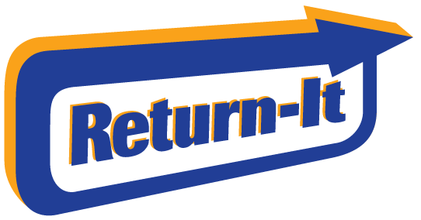
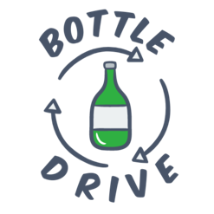

BOTTLE DRIVE FUNDRAISER
Dear Blair families,
We are pleased to announce our first Playground Fundraising event starting Monday March 28th and running until Friday April 22nd (Earth Day). We will be having a Bottle Drive, where we can connect with our community, teach our children the value of sustainability and reducing our carbon footprint.
To minimize the physical distancing, an account has been set up at any Return – It Express Depot in Richmond to allow our children and families to return their cleaned and recyclable bottles. You will enter the school’s phone number 604-668-6330 to log in at the kiosk and print the bag labels, remember one label per bag. Families are reminded to set up a unique PIN to access doors at the Express Depot to drop off bottles. If families are unavailable to drop off bottles to the recycling depot, please have your children drop off their cleaned, recyclable bottles to class for collection.
We’d want to take this opportunity to teach our children the importance of Earth Day and how we can protect our environment and prevent climate changes. We will also be handing out some prizes for the most bottles collected to our classes and students.
Thank you for your participation and together we can make a difference, one bottle at a time.

Playground Committee

