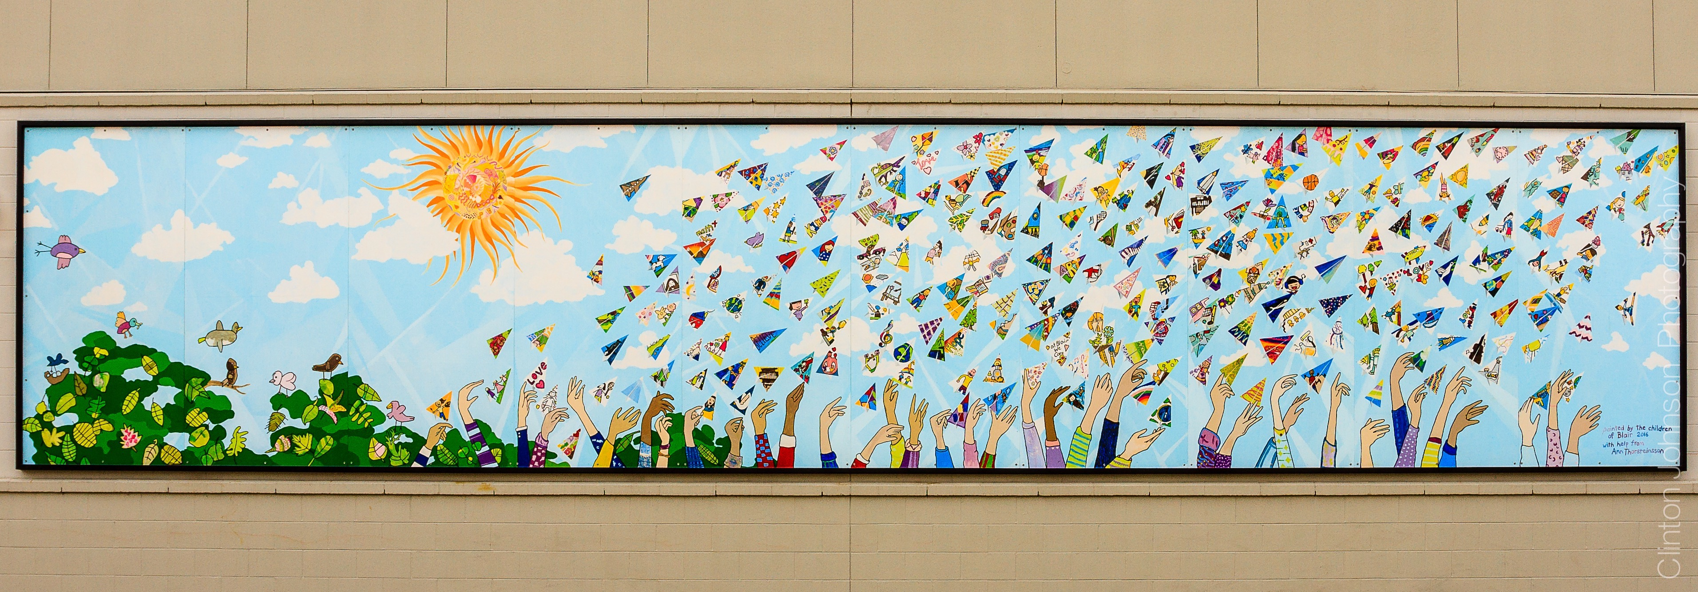

**6551 Lynas Lane, Richmond, BC V7C 3K8 | 604-668-6330 | Early Earning 604 668-6318**

**BLAIR**

**ADMINISTRATIVE REPORT**

|  |  |
| --- | --- |
| Be safe and responsible | • Staffing Update: Leaving: Mr. Mike Brown 6/7, Mr. Colin Chan RT/ELL, Ms. Karen Sato Gr. 2/3, and Ms. Nural Sumbultepe- ELL  • Welcoming: Ms. Wennie Jang, Ms. Jody Zhou  ELL/RT- 1.0 and .4   * Enrolment update: 242 We are a “full” school with waitlist of 35-40 students * Please wear hat, bring water and sunscreen for June! |
| Lend A Helping Hand | * Caught Caring Intiative: Blair Cares for self, others and place * Summer Garden Care! – families needed for watering please   email Mrs. Ridley |
| Always be Respectful | • Report cards will be digital and posted on e-portfolio and  on Myed Parent Portal  • A BIG thank-you to our PAC executive. It has been a less challenging year, but a successful one in many ways.  • Our staff thanks the PAC for supporting their classes with a  Teacher Allotment!  • School Wish List purchases: Sensory materials |
| Include everyone | * Grade 7 Graduation – June 24th @ 9:00 2 guests per family * Recognition Assembly and Farewell to teachers with students only. * June 29th – LAST DAY for students * Confirmed 2 Fine Arts performance for next year. Drumming/Acrobatic performance |
| Resolve Problems | • School Calendar and timetable – Regular schedule for the  fall 12:00-12:52 lunch hour- Eat first, then play. No drop off  lunch continued for the fall. Recess 9:55-10:10. Students will  continue to meet outside at 8:40 and be picked up outside  at 2:45. No eating outside- less garbage on school grounds. |

=