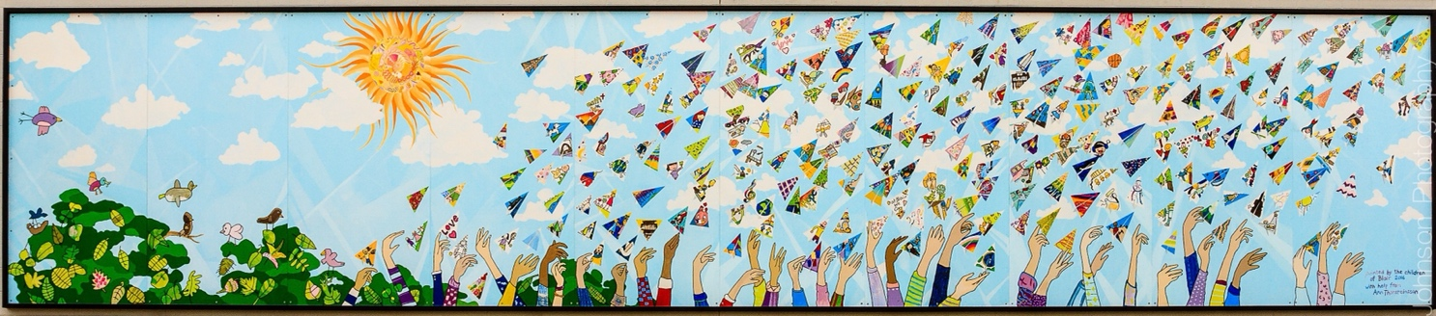

**BLAIR ADMINISTRATIVE REPORT**

**6551 Lynas Lane, Richmond, BC V7C 3K8 | 604-668-6330 | Early Earning 604 668-6318**

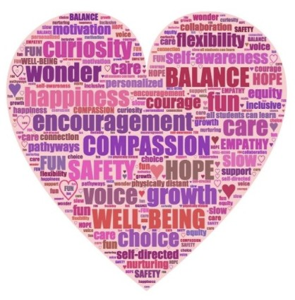

Be safe and responsible

Lend A Helping Hand

Always be Respectful

Include

everyone

* CSL -Conferences/Report Cards- March 2nd 12pm dismissal
* On-line safety- age guidelines for video games

• Blair Wear- Orders due on Friday, Feb. 24th

• Student Leadership Pink Day/Kindness School-wide activities: Catching Kindness/T-shirt design and Kindness Chain

•SEL focus: Blair Cares Framework- LES and Blair Studio/Learning Highlights newsletter

•SEL Family Night- April 12th- 6-7 pm. Come and Learn about SEL and experience some of the skills and strategies happening in classrooms.

•Basketball Breaker Classic- March 7th and 8th at 2pm-5:30.

•Percussion Workshop- Grade 6/7

Resolve

Problem • Student Learning Survey: Gr. 4 & 7 and parents- by April

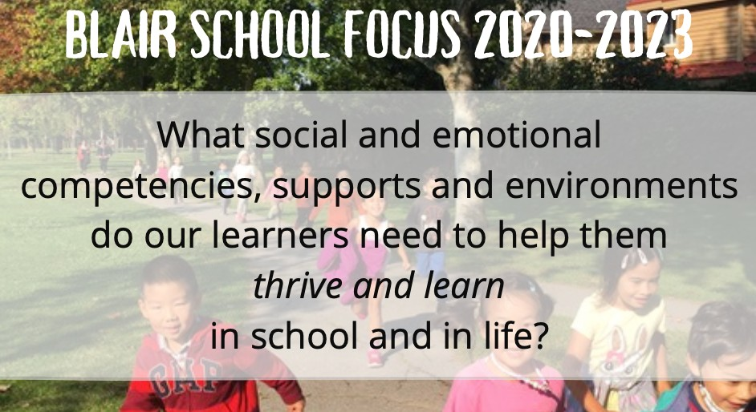1

2